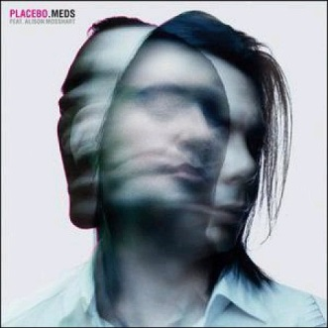
We, as a society, are drugged!
By: Marie-Clarisse Rochon
First year college student in
Business and Law

In our society today, doctors, pharmacists and
nurses are easily accessible for consultation. Therefore,
more and more people take advantage of this, and for every
slight problem they feel within their physical or mental
health, a doctor is the solution. This is quite normal, but
what if doctors weren’t always the solution? With only a
piece of paper with complicated names on it, most
frequently called a prescription, we feel relieved that all
our problems disappear. In reality, in many cases of renewable prescriptions, medicine can cause more problems than solutions.

Interview :
Amelie Legare, a patient at the CLSC de la Jacques Cartier has accepted our demand to interview her in order to have a relevant person’s opinion on the subject. Being only 18 years old and having to take 6 different kinds of pill each day, we were shocked to hear some of her answers to our questions. Amelie has been diagnosed with an anxiety disorder along with fragility to depressions and dependence. She has been seeing a psychologist and psychiatrist for over a year now in Quebec City. We asked her several questions including these:
1) Do you believe that after one year of taking medication, your situation has gotten better?
Medication only helps me to stay calm in a day. If one day I forget to take some, I am more at risk of panicking or having a tantrum. In reality, it hasn’t really helped me because now I have dependence to my medication that I know I will have extreme difficulty to get away from.
2) Have you ever noticed changed in yourself or side effects ever since you have started taking medication?
The major change that I have, like I mentioned before, is my dependence to my medication. I know that because when I forget to take them I quickly feel a change in my mood, my anxiety increases and my patience decreases. I know that the medication causes unnatural effects to my body.
3) Have you ever thought of stopping taking your medication for another solution?
I wish I could, but I depends a lot of my psychologist; what she thinks is best for me. I think that my dependence is too high to be able to stop, but if not, I would have to stop my medication slowly in order for my body to adjust itself again.

Street Talk and New theories

Our magazine targets people from all ages, therefor we had a street shout out to different types of people. We explained our problem, identified the fact that we believe too many people take medication and we asked their opinions. Many people agreed with us and suggested interesting ideas in order to improve this problem.
-“My mother is a homeopathic doctor. I believe in natural cures and natural technology. I strongly believe that homeopathy can replace medication.” –
Ann-Marie Boucher, 47 years old.
-“I think that just talking to someone can relieve a lot of mental pain felt by someone. Talking regularly to a psychologist or to groups of people with the same problem can be very helpful and can help replace unnecessary medication.” – Ayman Skamate, 20 years old.

We believe that many different ways of solving physical or mental illness exist and are developing. Yoga, physiotherapies, massage therapies , homeopathy, group consultations, psychologists etc are all solutions in order to replace unnecessary medication and over prescribing. We wish to see a decrease in our society using medication, because we strongly believe that in controversy to being helpful, medication is harmful to the being to consume them regularly. Raise the awareness!
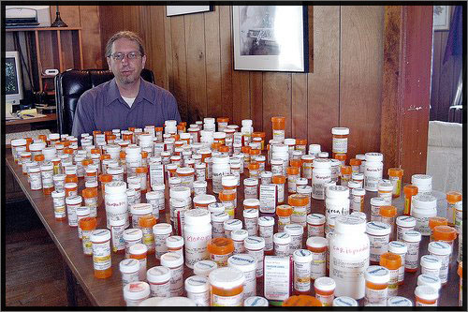

Medication vs. drugs
By: Steven Ferlatte
Steven Ferlatte is a second-year college student in Business and law

After proceeding to a lot of research concerning the case of the abuse of medication, we discovered that de society as known today is living with a major problem without noticing. The results that we have after the survey are pretty interesting. We realized that almost everyone in our society have already take medications. But the worst of it is that the majority of them have no idea of the side that medications can have on a person.
Now days, drugs are illegal to the general public. It is not well seen to consume drugs. But, to our society it is legit to take medications without even knowing that drugs and medications comes from the same and exact place, that they have the side effects, the same composites, the same medical name and what do people ignore is that there is a lot of medication that are still considered as drugs.
When someone gets hurt, that person goes to the hospital to see a doctor and without knowing what the consequences are on his body and will take all type of medications prescribed by the doctor and that will never think about de bad effects on him because it is called medications and it is given by a doctor. But what if those side effects happened to you? Because de treatment is not good for you or the medicine made an error while giving you your treatment. It is not impossible, the error is human and nobody is really asking them de question if the medication is really good for them. The side effects that you can have while taking medications are the same that you can have while taking drugs.
Now, let’s look at the type of medication and drugs that are associated to them. One of category that I want to show is the nervous system stimulants known as amphetamines among the trademarks of Benzedrine, Dexe-ephedrine, Methedrine manly use to help children’s at school. Under the effect of amphetamines, a person is more active, responds more quickly to stimuli, resist sleep and loss of appetite. This category to me is very important to look at because amphetamines is mostly prescribed to young children by doctors and parents don’t even know that these medications are associated to hard drugs such as crystal, meth and speed.
It is time for you know society to realize the situation in which we are. Being ignorant about medication, now days can be very dramatic for a person. Medications isn’t always a solution there down sides about it and the fact is that we as a society are on drugs.

Is medication really helping?
By: Steven Ferlatte
Steven Ferlatte is a second-year college student in Business and law

After a lot of research, we have found a lot of information and statistics that proved a major problem concerning medication. To prove our point of view, we have made a survey and a technical report that shows the impact of medications on the society. About everyone has already at least taken once medication and that’s a problem. But one of the treatments that we are going to stop on is a treatment for people how have psychological problems. This medication is mostly consumed by people from 10 to 20 years old and it is called Conserta.
Why do they take this kind of medication? It’s simple. Conserta is a psycho stimulant drug also known as Methylphenidate that is used to help people with problem such as ADHD (Attention-Déficit hyperactivity discorder). Its primary function is to ‘’reducing the reuptake of dopamine and norepinephrine’’ which helps the brains abilities. That’s why this treatment has become very popular since the past 20 years because it helps students at university, college, secondary and even primary level to have more success in class. Concerta stimulates your brain and pushes it to another level and makes you kind of your effective.
Now, let’s talk a little bit about the down sides of this drug. When we come to medication, it is very important to know and understand the side effects of those treatments. Since it is medication and that it is proved by a doctor, people tend to ignore those side effects that could be catastrophic for someone. Only because that person trusted a little bit to mush a doctor.
Methylphenidate has many side effects and it is a major problem because more we advance more starts taking Concerta without noticing those side effects that are very harmful and that can even lead to sudden death. agitation, nervousness, or anxiety,diarrhea, dizziness or drowsiness, dry mouth, headache, heartburn, joint pain, loss of appetite, nausea or vomiting, skin rash or itching (mild), stomach pain, trouble sleeping, chest pain, confusion, fever, hallucinations (hearing, seeing, or feeling things that are not actually there) or abnormal thoughts or behaviour, increased blood pressure, muscle twitching or tics, palpitations (feeling your heart beat quickly or irregularly), pinpoint-sized red spots on skin or unusual bruising prickling or tingling sensations in the hands, arms, feet, or legs sore, throat and fever, sudden high fevers, weating symptoms of depression (e.g., losing interest in your usual activities, feeling sad, having thoughts of suicide), symptoms of liver damage (e.g., yellow skin or eyes, abdominal pain, loss of appetite, pale stools, dark urine), tics or symptoms of Tourette's syndrome (involuntary, sudden body movements, or uncontrolled vocal outbursts), vision changes, convulsions (seizures), peeling or blistering of the skin, signs of a serious allergic reaction (difficulty breathing; hives; swelling of the face, lips, eyes, mouth, or throat), thoughts of suicide or hurting yourself.
As you can see, side effects concerning medications can be very dramatic and can even cause death. Concerta is a dangerous treatment and when we look at how this medication is so popular, we realize that there are a lot of people that can be in danger right know. So before taking any treatments against pschological problem, inform yourself on the side effects and if you have some, go check with your doctor before it’s to late.
http://chealth.canoe.ca/drug_info_details.asp?brand_name_id=1916&page_no=2

